Homemade Tater Tots

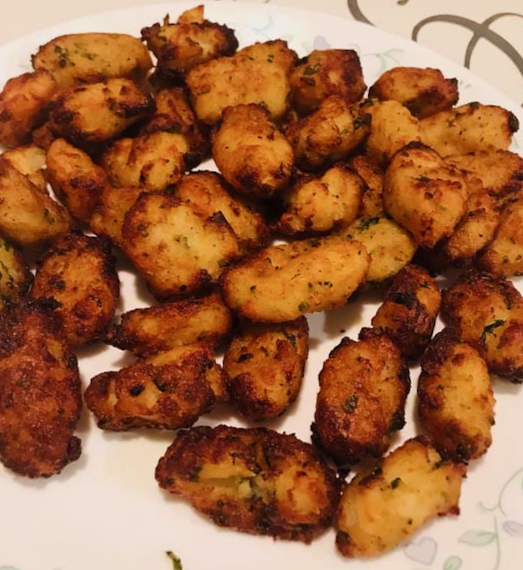

Tater tots have become one of the favorite snacks of people during pandemic time. Staying home or working from home and bored we are in need of crunchy snacks! Up until recently we always got store brought frozen tater tots and fried in the airfyer. They are so yummy that no matter how many bags of frozen tater tots I buy they get vanished so fast! That’s when I decided to try making them from home from scratch! And believe me it is faster than I thought! Get your family involved! Get your kids to peel the potatoes, delegate your partner to cook the potatoes and take help from the grown-up kids to grate them and roll them! You will see this get done in no time!

Ingredients

* Potatoes 8
* All-purpose flour 2 tbsp
* Parsley finely chopped 2 tbsp
* Garlic powder 1 tbsp
* Black pepper powder 2 tsp
* Salt as needed
* Oil for frying (If using deep fry method)

Method

 Peel the skin and wash the potatoes. Place them in the instant pot and add water till it is one inch above the potatoes. Turn on the instant pot to manual and cook for 4 minutes. The potatoes should only be parboiled.

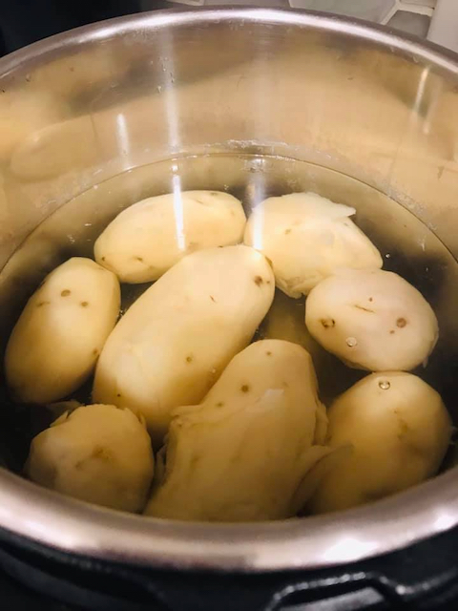

When done, release pressure after about 5 minutes. Scoop the potatoes off the water and pat dry with paper towel and let it cool.

If not using an instant pot, the potatoes can be cooked in a regular pot. Just add water one inch above the level of potatoes and cook till they are partially cooked.

Grate the potatoes with a grater and squeeze off the water if any left. Add all the rest of the ingredients except oil and mix. Do not mash the potatoes. Make tiny tubular tots of the potatoes and place in a plate. Keep the surface of the tots rough as it is. Do not try to smoothen the surface.

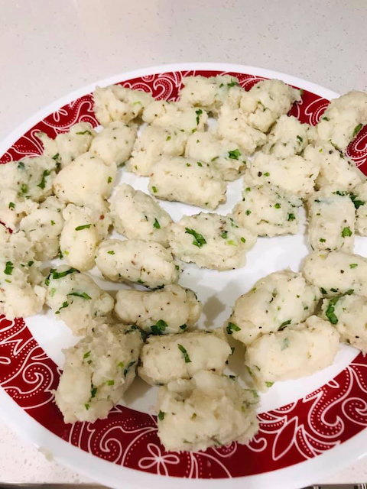

Airfryer method: Turn on the airfryer to 380 deg F for 10 minutes. Place the tots in the airfryer basket without crowding them. Spritz some cooking spray and airfry them.

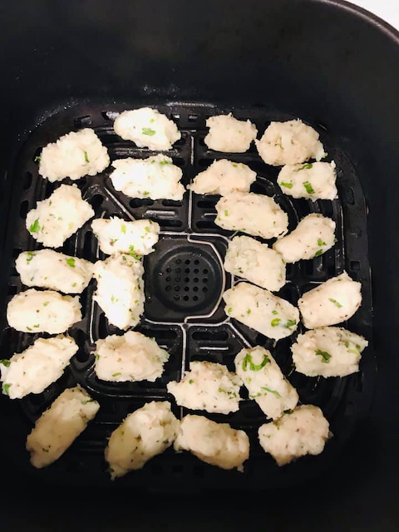

Shake them frequently so the tots are evenly fried. After 10 minutes switch the temp to 400 deg F and airfry for another 5 minutes or till they turn brown.



Oven Method:Preheat oven to 400 deg F. Place the tater on a baking sheet and spritz with some cooking spray and bake for about 20 minutes or till they are browned.  
Deep fry method:Heat oil in a pan and fry the tots till they turn crispy and brown. Dry in a paper towel.  
  
Serve hot with your favorite dip!  
Notes:

1. The leftover fried tater tots can be frozen and used later.

2. Russet potatoes are best for taters.